**Steps to setup three node Elasticsearch cluster on CentOS**

**Step 1: Install Java**

As I mentioned in prerequisites, Elasticsearch needs Java, so we need to install Java first. To install Java on CentOS, please execute the following command:

yum install java-1.8.0-openjdk

Execute “**java -version**” and make sure the Java is installed correctly.

* java -version

**Step 2: Download the Elasticsearch RPM**

curl -L -O https://artifacts.elastic.co/downloads/elasticsearch/elasticsearch-6.7.2.rpm

You can download the latest version from here >> [Download Elasticsearch](https://www.elastic.co/downloads/elasticsearch) << In this page you can see all the packages, RPM, DEB etc…

**Step 3: Install using RPM**

rpm -i elasticsearch-6.7.2.rpm

**Step 4: Start / Enable service**

systemctl daemon-reload  
systemctl enable elasticsearch.service  
systemctl start elasticsearch.service

Installation part is done. Once you installed it on all three servers, you can start editing the configuration to setup the cluster using these three nodes.

The Elasticsearch configuration file is located here: **/etc/elasticsearch/elasticsearch.yml**

Before making changes in the configuration make sure that the port **9200** and **9300** are open between the nodes in the cluster. Add firewall rules accordingly. Try **telnet** / **nc** and make sure that the connections are okay between nodes..

## ****Step 5: Set minimum memory for JVM****

By default, the minimum memory set for JVM is **2gb,**if your server has small memory size, change this value in **/etc/elasticsearch/jvm.options**

-Xms2g

-Xmx2g

Change the value to a minimum based on the memory available on your servers. Examples, **-Xms512m** or **-Xms1g** etc

## ****Step 6: Create a Data Directory for Elasticsearch**** (optional)

It’s better to attach a separate disk for Elasticsearch Data. If you have enough space on your primary disk, you can go ahead with that one. Just create a new directory and set relevant permissions to that directory.

mkdir /var/lib/elasticsearch/data  
chown -R elasticsearch:elasticsearch /var/lib/elasticsearch/data  
chmod -R 775 /var/lib/elasticsearch/data

## ****Step 7: Set Data Directory****

We already create a Directory for saving Elasticsearch Data, set that in configuration file.

path.data: /var/lib/elasticsearch/data

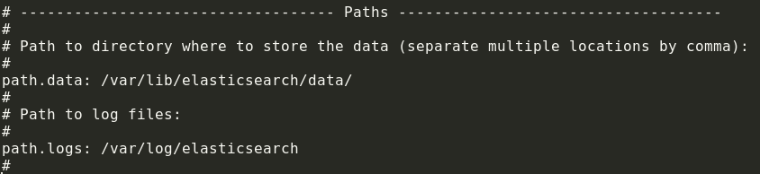

## ****Step 8: Configure Elasticsearch cluster****

As I mentioned, we have to make changes on this configuration file **/etc/elasticsearch/elasticsearch.yml** You have to make the following changes in configuration file to setup a cluster.

### **8.1: Stop Elasticsearch, if it’s running.**

systemctl stop elasticsearch.service

### **8.2: On all nodes, setup the cluster name:**

cluster.name: es-crybit

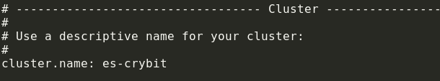

Open the configuration file on all the three servers and set the same name as cluster name.

### **8.3: Set node name for all nodes**

node.name: es1

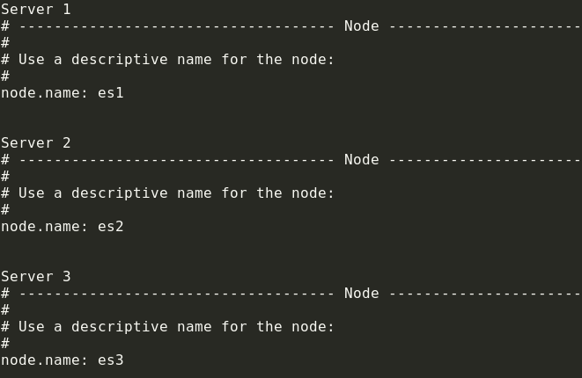

### **8.4: Bind an IP for Elasticsearch**

By default, the Elasticsearch process listen on 0.0.0.0 we need to assign the private IP.

network.host 10.10.10.10

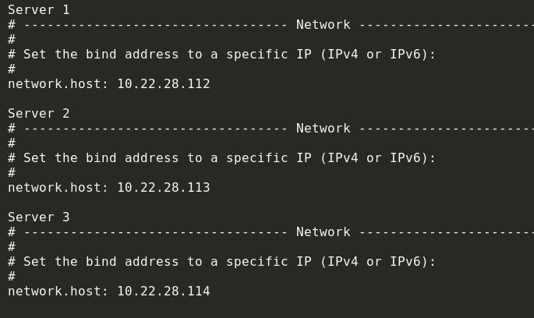

### **8.5: Set discovery by specifying all Nodes IP addresses (Add it on all nodes)**

discovery.zen.ping.unicast.hosts: ["10.22.28.112", "10.22.28.113", "10.22.28.114"]

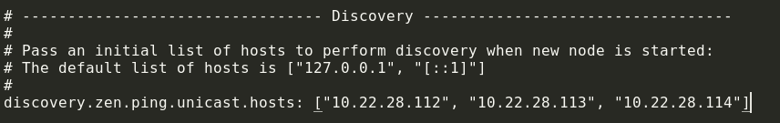

### **8.6: Specify the number of Master eligible nodes (Add it on all nodes)**

discovery.zen.minimum_master_nodes: 2

### **8.7: Define Data & Master nodes**

node.master: true  
node.data: true

This you can add based on your requirement. I added it on all nodes.

### **8.8: Start Elasticsearch**

systemctl start elasticsearch.service

That’s it your cluster is ready. Now you need to check the cluster health and make sure that the cluster is ready for Production use.

Run the following curl call and make sure that the cluster status is Green:

curl http://10.22.28.112:9200/_cluster/health?pretty